Dijkstra’s Algorithm **(25/Apr/2020)**

**Source Code :**

#include<iostream>

using namespace std;

int findMinVertex(int* distance , bool* visited , int n)

{

int minVertex = -1;

for(int i = 0 ; i<n ; i++)

{

if(!visited[i] && (minVertex == -1 || distance[i] < distance[minVertex]))

{

minVertex = i;

}

}

return minVertex;

}

void dijsktra(int **edges , int n)

{

int *distance = new int[n];

bool* visited = new bool[n];

for(int i=0; i<n ; i++)

{

distance[i] = INT_MAX;

visited[i] = false;

}

distance[0]=0;

for(int i=0; i<n-1; i++)

{

int minVertex = findMinVertex(distance , visited , n);

visited[minVertex] = true;

for(int j=0; j<n; j++)

{

if(edges[minVertex][j] != 0 && !visited[j])

{

int dist = distance[minVertex]+edges[minVertex][j];

if(dist<distance[j])

{

distance[j]=dist;

}

}

}

}

for(int i=0; i<n; i++)

{

cout<<i<<" "<<distance[i]<<endl;

}

}

int main()

{

int n,e;

cout<<"Enter Edges and Vertices : ";

cin>>n>>e;

int**edges=new int*[n];

for(int i=0; i<n; i++)

{

edges[i] = new int[n];

for(int j=0; j<n; j++)

{

edges[i][j]=0;

}

}

for(int i=0; i<e; i++)

{

int f,s,weight;

cin>>f>>s>>weight;

edges[f][s] = weight;

edges[s][f] = weight;

}

cout<<endl;

dijsktra(edges,n);

return 0;

}

**OUTPUT**

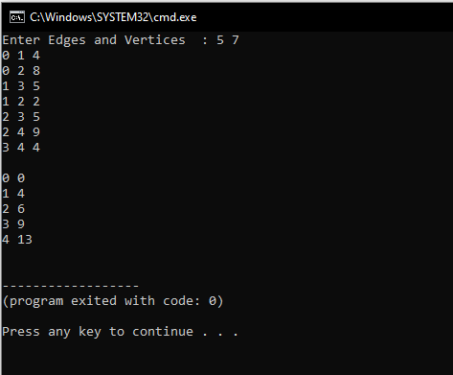

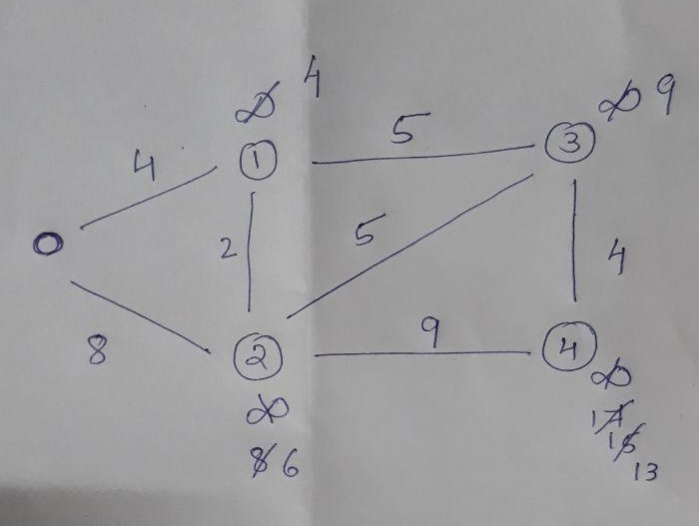

[**https://github.com/harinarayanank/18CA382-Competitive-Lab**](https://github.com/harinarayanank/18CA382-Competitive-Lab)